

|  |  |
| --- | --- |
| **Name** | **Sumaiya Shehzadi** |
| **Class** | **BS-AI** |
| **Reg. No** | **22-NTU-CS-1376** |
| **Lab** | **IOT** |
| **Submission Date** | **20-2-2025** |
| **Submission To** | **Sir Nasir** |

Task1_

# Task Questions:

# Upload the same code to a physical ESP32 S3:

# Run the code.

**Code Screenshot:**

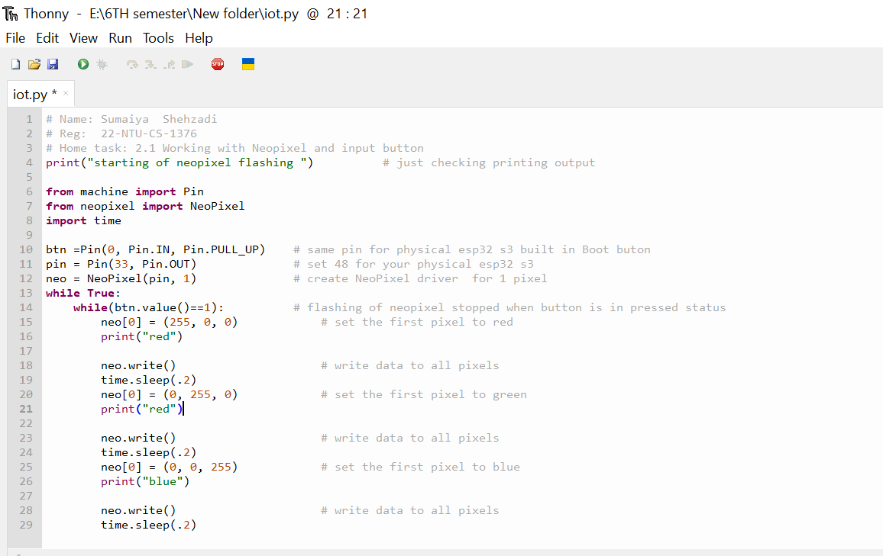

**Output:**

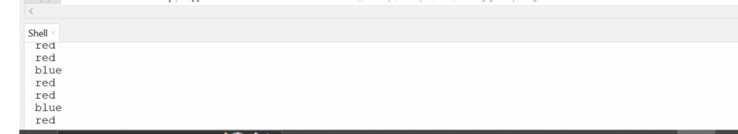

Task_2

# Investigate the Neopixel color behavior:

# Why does the Neopixel always turn blue when the button is pressed?

# How can it be made to stop on different colors in real-time (e.g., sometimes red, sometimes green, sometimes blue)?

# Modify the code for button presses:

**Ans**: The LED always turns blue because, in the code, the button value starts at 1, making the loop run. When we press the button, the value changes to 0, stopping the loop. Since blue is the last color in the loop, the LED always stops at blue.

To make the LED stop at different colors, we can use a list of colors and a variable (like color index) to keep track of which color is currently displayed. By updating color_index before stopping the loop when the button is pressed, the LED will stay on the color it was showing at that moment. This way, it won’t always stop at blue but at different colors instead.

**Code Screenshot:**

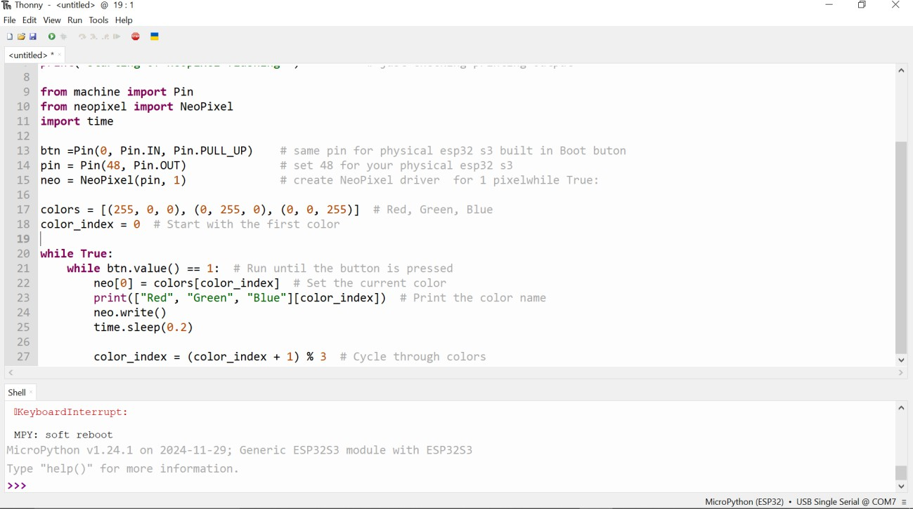

Task_3

# Change the color after every 5 button presses.

# Examine the result: Does the color change exactly after 5 presses, or is there abnormal behavior?

# If there is abnormal behavior, what could be the reason?

**Ans:** If there is abnormal behavior, it might be due to:

* **Button bounce** – The button might register multiple presses when pressed once.
* **Press detection issues** – The code may not be detecting presses correctly.
* **Unstable power supply** – The LED or microcontroller might not be getting steady power.
* **Loop not updating Neo_Pixel** – If the loop is stuck or not running properly, the LED may not change colors as expected.

**Code Screenshot:**

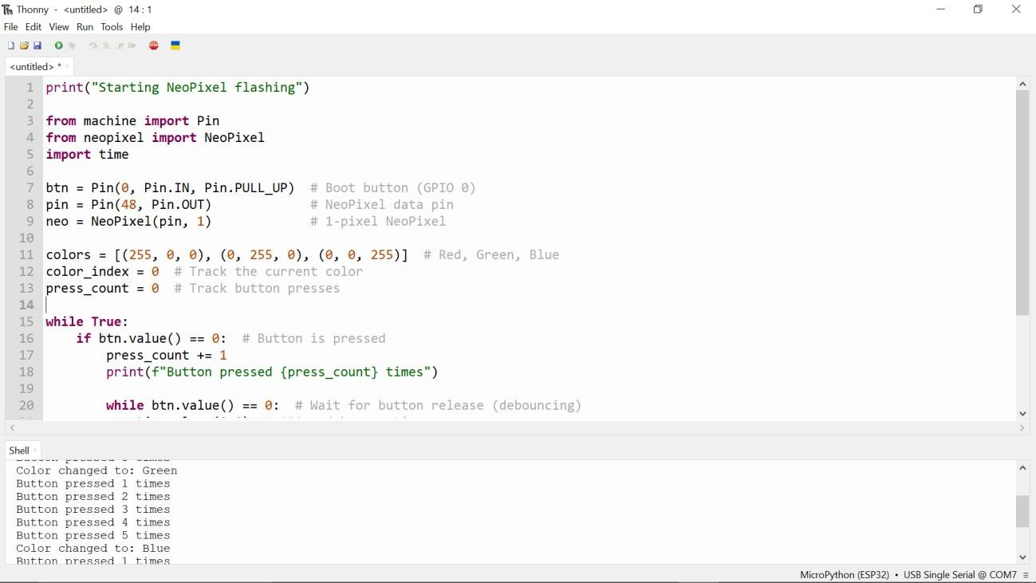

Task_4

# Make your own code modifications:

# Name: Sumaiya Shehzadi

# Reg: 22-NTU-CS-1376

# Home task: 2.1 Working with Neopixel and input button

print("Starting NeoPixel flashing") # Checking output

from machine import Pin

from neopixel import NeoPixel import time

import random # Import random module for random colors

btn = Pin(0, Pin.IN, Pin.PULL_UP) # Same pin for physical ESP32 S3 built-in Boot button pin = Pin(48, Pin.OUT) # Set 48 for your physical ESP32 S3

neo = NeoPixel(pin, 1) # Create NeoPixel driver for 1 pixel

def random_color():

"""Generate a random RGB color."""

return (random.randint(0, 255), random.randint(0, 255), random.randint(0, 255))

while True:

while btn.value() == 1: # Run flashing effect when button is NOT pressed color = random_color() # Pick a random color

neo[0] = color # Set the pixel color

print(f"Flashing Color: {color}") # Debugging output neo.write() # Apply the color

time.sleep(0.5) # Delay for smooth flashing

# When the button is pressed, the NeoPixel turns off (or stops flashing) neo[0] = (0, 0, 0) # Turn off the LED

neo.write()

print("Button Pressed - LED Off")

time.sleep(0.2) # Short delay to prevent rapid button toggling

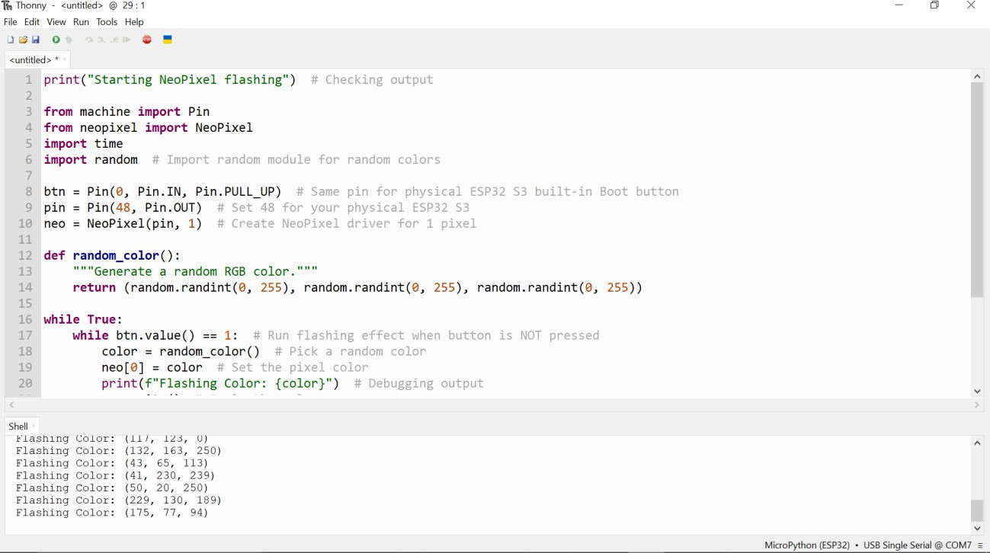

# Implement your own changes to the code.

# Submit the link to your Wokwi project for all tasks (no hardware changes required for any task). Ensure all questions are answered in your own words, and the code is written in your own style.

LINK WOKWI:

https://wokwi.com/projects/423324034802520065